Technical and Financial Proposal
AMER247 Website Redevelopment and Service Application Platform
____________________________________________

1. Introduction
This document presents the proposed technical and financial plan for rebuilding the AMER247 platform from scratch as a modern service-oriented website with structured content management, category-based application forms, blog pages, utility pages, and production deployment.
Based on the supplied page inventory, the current platform footprint contains 107 pages across main navigation pages, service/application form pages, blog detail pages, and utility pages. The largest effort area is the service application ecosystem, which spans AMER services, Emirates ID services, Golden Visa services, Medical Test services, and Insurance services.
- Scope is limited to software development, testing, deployment, and handover.
- Design, UI/UX, branding, and visual content creation are excluded and will follow client-provided design assets.
- Third-party fees such as hosting, SMTP, payment gateway, SMS, captcha, analytics, CDN, or monitoring subscriptions are excluded unless explicitly approved later.
- Any requirement outside the agreed scope will be handled through a change request process.
2. Project Understanding and Objectives
AMER247 appears to operate as an information and service-application platform for UAE-related visa, residence, Emirates ID, medical test, and insurance processes. The website requires a maintainable structure that allows administrators to update service pages, blog content, pricing-related information, and application forms without code-level dependency.
3. Proposed Technical Approach and Methodology
We recommend a structured monolithic web application architecture with a modern frontend, a secure backend/admin layer, reusable form configuration, and a relational database. Since the site includes a large number of similar service application pages, the solution should prioritize configurability, consistency, and manageable administration over one-off page builds.
- Component-based development for reusable page sections and shared service-page patterns.
- Configurable service-form engine so repeated fields, validations, uploads, and routing can be managed efficiently.
- Admin/CMS-driven management of pages, blog posts, service categories, service details, pricing text, FAQs, and legal pages.
- Environment-based delivery flow: local -> staging -> production.
- Milestone-based development with staged QA support, and release sign-off.
Delivery methodology will follow a practical phased implementation model with backlog confirmation, architecture setup, module development, QA cycles, support, and production deployment. This proposal intentionally excludes unnecessary expansion into features not evidenced by the supplied requirement
Set.

4. Proposed Technical Stack
Layer | Proposed Stack
Frontend | React.js
Backend / Admin API | Laravel
Database | MySQL
Content / Admin Management | Laravel admin panel with structured content modules
Rich Text / Media | Editor and media library within admin
Form Handling | Reusable dynamic form configuration, validation, document upload
Authentication | Role-based admin authentication
Hosting | Cloud VPS / AWS / managed Linux server
Web Server | Nginx
Version Control | Git-based repository workflow
CI/CD | Staging and production deployment pipeline

5. Scope of Work by Phase
To manage delivery risk and control implementation cost, the scope is divided into two development phases.
5.1 Phase 1 - Core Platform, Public Pages, and Reusable Service Framework
- Project setup, system architecture, database design, environment setup, and core repository structure.
- Frontend and backend foundation for the public website and admin platform.
- Development of key public pages: Home, Services, About, Contact, Pricing List, UAE Tourist Visa, Online Services, and utility/legal pages.
- Blog module development including news listing and news detail template.
- Admin modules for page content, blog management, service category management, FAQ / legal text management, and media management.
- Reusable service detail/page template to support category-based service publication.
- Reusable application form engine covering common input fields, validation rules, file upload handling, acknowledgement flow, and admin-side submission storage.
- Initial rollout of priority service categories and representative forms to validate the reusable framework.
- Staging deployment and Phase 1 QA support.

Role | Key Responsibility
Project Manager | Planning, backlog finalization, scope control, coordination, acceptance tracking
Tech Lead | Architecture, code standards, DB and module design, review
Backend Developer | Laravel backend, admin modules, APIs, form engine, database
Frontend Developer | Public website templates, page integration, frontend validation
QA Engineer | Test cases, regression, bug verification, QA support
DevOps Engineer | Server setup, deployment pipeline, staging and production readiness

5.2 Phase 2 - Full Service Form Rollout, Hardening, and Go-Live
- Rollout of the remaining service application pages based on the approved reusable form framework.
- Coverage of AMER service forms, Emirates ID forms, Golden Visa forms, Medical Test forms, and Insurance forms as listed in the supplied page inventory.
- Category-wise configuration of validation rules, required documents, service-specific labels, declarations, and admin mappings.
- Submission management enhancements for admin review, search, status visibility, and export-ready records where required.
- Content population support structure for all remaining page templates and page-wise QA review.
- Cross-browser testing, responsive testing, security checklist verification, performance tuning, and production release preparation.
- Production deployment, handover, and post-launch stabilization.

Role | Key Responsibility
Project Manager | Change tracking, rollout prioritization, release coordination
Tech Lead | Solution review, final optimization, release sign-off support
Backend Developer | Service-form rollout, submission workflow completion, hardening
Frontend Developer | Template completion, final integrations, responsive polish
QA Engineer | End-to-end testing, retesting, release readiness
DevOps Engineer | Production deployment, backup, monitoring, go-live support
6. Deliverables
- Production-ready AMER247 website developed from scratch based on the approved design assets and supplied page inventory.
- Admin panel for content, blogs, service categories, service pages, and service application submissions.
- Reusable configurable service-form framework to support large-scale service application page management.
- Configured database, file-upload handling, role-based admin access, and environment setup.
- Staging and production deployment support.
- QA artifacts including test checklist, bug log, regression status, and go-live verification notes.
- Technical handover and deployment/configuration notes.
7. Testing and Quality Assurance
- Module-level functional testing for pages, content modules, forms, uploads, and admin workflows.
- Validation testing for required fields, document upload rules, and submission behavior.
- Responsive and browser compatibility testing for major desktop and mobile browsers.
- Regression testing before each phase sign-off and before production release.
- Basic security and input-handling checks for public forms and admin authentication.
- QA issue support and controlled defect-fix cycle before go-live.
8. Technical Diagram
Diagram 1: High-Level Solution Architecture
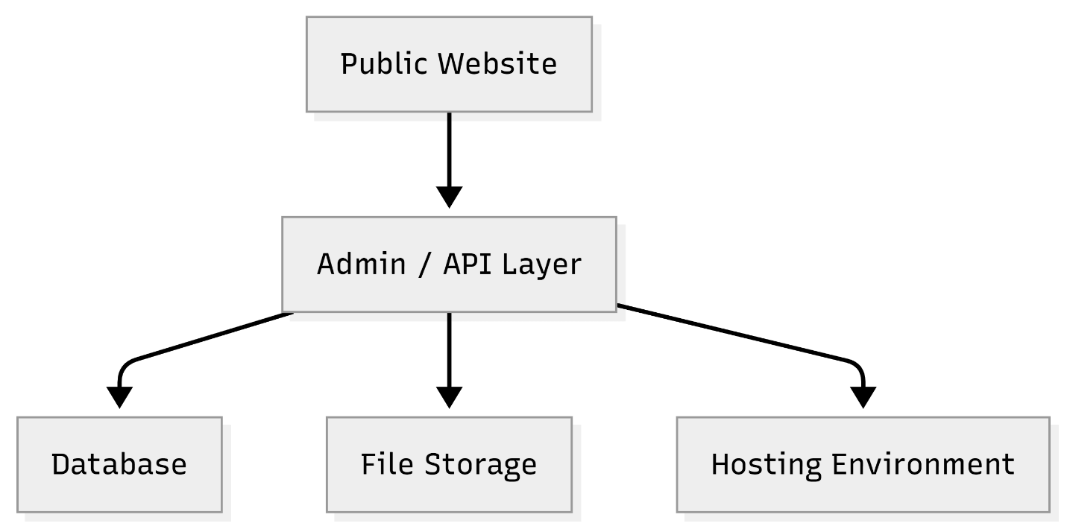

Diagram 2: Service Application Submission Flow
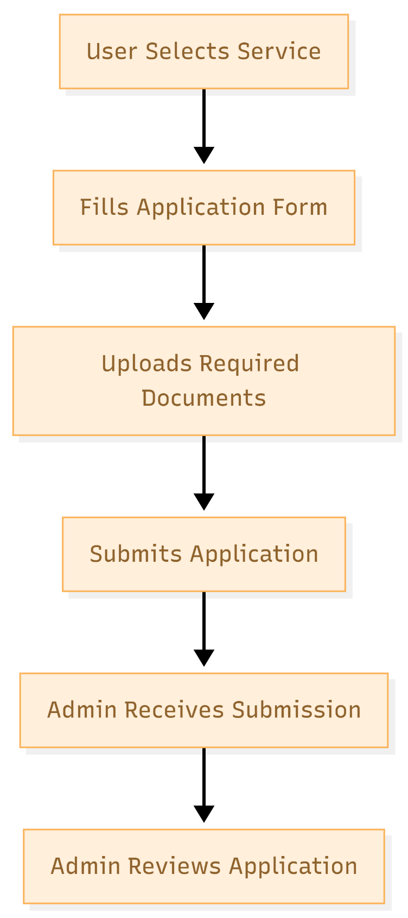

9. Complimentary Support
After final production launch and formal handover, we will provide 1 months of complimentary support for the delivered scope.
- Bug fixing for reproducible defects within the delivered modules.
- Minor adjustment within existing screens, forms, labels, and configuration.
- Release monitoring and deployment support for issues directly related to the delivered build.
The complimentary period does not include new modules, major workflow changes, design revisions, or third-party policy changes.

10. Financial Proposal
The financial estimate below is aligned with a controlled two-phase delivery model and excludes UI/UX design cost and third-party subscription/licensing fees.
Phase | Scope Summary | Timeline | Estimated Cost (USD)
Phase 1 | Core platform, public pages, blog module, admin foundation, reusable service-page and form framework, initial rollout | 2 weeks | $2710
Phase 2 | Remaining service form rollout, submission workflow completion, QA hardening, deployment and handover | 1 weeks | $1100
Total |  | 3 weeks | $ 3810
10.1 Payment Terms
- 30% advance payment upon project kickoff.
- 30% payment upon completion and sign-off of Phase 1 deliverables on staging.
- 30% payment upon completion of Phase 2 deliverables and sign-off.
- 10% payment upon production launch, final handover, and project closure.

10.2 Change Request (CR)
- Any requirement beyond the defined scope will be treated as a Change Request.
- CR Man-day Rate: USD 150 per man-day or USD 25 per man-hour.

10.3 Assumptions and Commercial Notes
- Final approved design files, page content, service text, labels, and document lists will be provided by the client.
- If payment gateway, OTP/SMS, or external government/system integrations are later required, those will be treated as change requests unless already confirmed in writing.
- Bulk content entry and translation are excluded unless separately agreed.
- Third-party infrastructure, gateway, hosting, domain, SSL, email, captcha, and similar service charges are excluded from this proposal.
- Any requirement outside this scope will be estimated separately through a change request.
11. Proposed Out of Scope
- UI/UX design, branding, design system creation, and visual asset design.
- Custom mobile app development.
- Unconfirmed external system integrations not evidenced in the supplied requirement materials.
- Ongoing SEO campaign management, paid marketing setup, or content writing services.
- Long-term support beyond the complimentary support period.
12. Acceptance and Sign-Off
Each phase will be considered accepted once the agreed deliverables are implemented, internally tested, deployed to the agreed environment, and signed off by the client or authorized representative. Production release will proceed after closure of critical issues and completion of the release checklist.

